**Price Paid Per Unit of Car by Months**

One of our inputs in the Regression and correlation analysis was the price paid per unit of electric cars. The data can be seen below and this would make it difficult to use the data.

The data obtained was secondary data that gave sale by months and below table is the aggregate of the Year this data was then normalized to create the input data by months

|  |  |  |  |  |  |  |  |  |  |  |  |  |  |  |  |  |  |  |  |  |  |  |  |  |  |  |  |  |  |  |  |  |  |  |  |  |  |  |  |  |  |  |  |  |  |  |  |  |  |  |  |  |  |  |  |  |  |  |  |  |  |  |  |  |  |  |  |  |  |  |  |  |  |  |  |  |  |  |  |  |  |  |  |  |  |  |  |  |  |  |  |  |  |  |  |  |  |  |  |  |  |  |  |  |  |  |  |  |  |  |  |  |  |  |  |  |  |  |  |  |  |  |  |  |  |  |  |  |  |  |  |  |  |  |  |  |  |  |  |  |  |  |  |  |  |  |  |  |  |  |  |  |  |  |  |  |  |  |  |  |  |  |  |  |  |  |  |  |  |  |  |  |  |  |  |  |  |  |  |  |  |  |  |  |  |  |  |  |  |  |  |  |  |  |  |  |  |  |  |  |  |  |  |  |  |  |  |  |  |  |  |  |  |  |  |  |  |  |  |  |  |  |  |  |  |  |  |  |  |  |  |  |  |  |  |  |  |  |  |  |  |  |  |  |  |  |  |  |  |  |  |  |  |  |  |  |  |  |  |  |  |  |  |  |  |  |  |  |  |  |  |  |  |  |  |  |  |  |  |  |  |  |  |  |  |  |  |  |
| --- | --- | --- | --- | --- | --- | --- | --- | --- | --- | --- | --- | --- | --- | --- | --- | --- | --- | --- | --- | --- | --- | --- | --- | --- | --- | --- | --- | --- | --- | --- | --- | --- | --- | --- | --- | --- | --- | --- | --- | --- | --- | --- | --- | --- | --- | --- | --- | --- | --- | --- | --- | --- | --- | --- | --- | --- | --- | --- | --- | --- | --- | --- | --- | --- | --- | --- | --- | --- | --- | --- | --- | --- | --- | --- | --- | --- | --- | --- | --- | --- | --- | --- | --- | --- | --- | --- | --- | --- | --- | --- | --- | --- | --- | --- | --- | --- | --- | --- | --- | --- | --- | --- | --- | --- | --- | --- | --- | --- | --- | --- | --- | --- | --- | --- | --- | --- | --- | --- | --- | --- | --- | --- | --- | --- | --- | --- | --- | --- | --- | --- | --- | --- | --- | --- | --- | --- | --- | --- | --- | --- | --- | --- | --- | --- | --- | --- | --- | --- | --- | --- | --- | --- | --- | --- | --- | --- | --- | --- | --- | --- | --- | --- | --- | --- | --- | --- | --- | --- | --- | --- | --- | --- | --- | --- | --- | --- | --- | --- | --- | --- | --- | --- | --- | --- | --- | --- | --- | --- | --- | --- | --- | --- | --- | --- | --- | --- | --- | --- | --- | --- | --- | --- | --- | --- | --- | --- | --- | --- | --- | --- | --- | --- | --- | --- | --- | --- | --- | --- | --- | --- | --- | --- | --- | --- | --- | --- | --- | --- | --- | --- | --- | --- | --- | --- | --- | --- | --- | --- | --- | --- | --- | --- | --- | --- | --- | --- | --- | --- | --- | --- | --- | --- | --- | --- | --- | --- | --- | --- | --- | --- | --- | --- | --- | --- | --- | --- | --- | --- | --- | --- | --- | --- | --- | --- | --- | --- | --- | --- | --- | --- | --- | --- | --- | --- | --- | --- | --- | --- |
| The original cost of all cars as depicted below the outliers such as the Porsche 918 Spyder and Others were removed from the calculation as they were outliers or undeterminable   |  |  |  |  |  |  |  |  |  | | --- | --- | --- | --- | --- | --- | --- | --- | --- | | Car Model | Average | 2010 | 2011 | 2012 | 2013 | 2014 | 2015 | 2016 | | Audi A3 Sprtbk e-tron | $ 37,900 | 0 | 0 | 0 | 0 | 0 | 98 | 907 | | BMW i3 | $ 43,395 | 0 | 0 | 0 | 0 | 6092 | 11024 | 762 | | BMW i8 | $ 141,695 | 0 | 0 | 0 | 0 | 555 | 2265 | 171 | | BMW x5 xDrive40e | $ 63,095 | 0 | 0 | 0 | 0 | 0 | 892 | 839 | | Cadillac ELR | $ 64,995 | 0 | 0 | 0 | 12 | 1310 | 1024 | 262 | | Chevrolet Spark EV | $ 25,995 | 0 | 0 | 0 | 2310 | 1145 | 2629 | 607 | | Chevrolet Volt | $ 33,995 | 326 | 7671 | 23461 | 23094 | 18805 | 15393 | 3987 | | Fiat 500 e | $ 32,780 | 0 | 0 | 0 | 2310 | 5132 | 6194 | 840 | | Ford C-Max Energi | $ 32,645 | 0 | 0 | 2374 | 7154 | 11550 | 7591 | 1450 | | Ford Focus Electric | $ 29,995 | 0 | 0 | 680 | 1738 | 1964 | 1582 | 257 | | Ford Fusion Energi | $ 34,775 | 0 | 0 | 0 | 6089 | 11550 | 9750 | 2751 | | Honda Accord PHV | $ 39,780 | 0 | 0 | 0 | 526 | 449 | 64 | 0 | | Honda Fit EV | $ 36,625 | 0 | 0 | 93 | 569 | 0 | 0 | 0 | | Hyundai Sonata PHV | $ 35,435 | 0 | 0 | 0 | 0 | 0 | 160 | 650 | | Kia Soul EV | $ 32,800 | 0 | 0 | 0 | 0 | 718 | 1015 | 220 | | Mercedes B250e | $ 42,375 | 0 | 0 | 0 | 0 | 0 | 0 | 161 | | Mercedes B-Class ED | $ 41,450 | 0 | 0 | 0 | 0 | 774 | 1906 | 0 | | Mercedes S550H PHV | $ 96,575 | 0 | 0 | 0 | 0 | 0 | 118 | 38 | | Mitsubishi i-MiEV | $ 23,845 | 0 | 80 | 588 | 1029 | 196 | 115 | 8 | | Nissan LEAF | $ 29,860 | 19 | 9674 | 9819 | 22610 | 28087 | 17269 | 2931 | | Other | $ - | 0 | 0 | 0 | 0 | 0 | 34 | 0 | | Porsche 918 Spyder | $ 845,000 | 0 | 0 | 0 | 0 | 0 | 203 | 0 | | Porsche Cayenne S-E | $ 78,250 | 0 | 0 | 0 | 0 | 200 | 1034 | 562 | | Porsche Panamera S-E | $ 94,250 | 0 | 0 | 0 | 86 | 879 | 380 | 83 | | Smart ED | $ 25,750 | 0 | 0 | 0 | 923 | 2594 | 1387 | 172 | | Tesla Model S | $ 88,700 | 0 | 0 | 2650 | 17650 | 16689 | 25202 | 6390 | | Tesla Model X | $ 81,200 | 0 | 0 | 0 | 0 | 0 | 214 | 2400 | | Toyota Prius PHV | $ 14,686 | 0 | 0 | 12750 | 12088 | 13264 | 4191 | 23 | | Toyota RAV4 EV | $ 49,800 | 0 | 0 | 192 | 1096 | 1184 | 0 | 0 | | Volvo XC90 | $ 69,095 | 0 | 0 | 0 | 0 | 0 | 86 | 580 | | VW e-Golf | $ 29,815 | 0 | 0 | 0 | 0 | 714 | 4232 | 612 | |

Data was taken by month for the sale of the vehicles from

|  |
| --- |
| <http://www.greencarreports.com/news/1080871_electric-car-price-guide-every-2015-2016-plug-in-car-with-specs-updated> |
| <http://www.autotrader.com/car-news/honda-reveals-price-of-electric-fit-136323>  <http://insideevs.com/monthly-plug-in-sales-scorecard/>  Basic cost google search  All Car Costs are average of all models per 2016 as per the publications above  Formula Used and then the Rendered chart below  Values  Three values were deciphered using same formula the values were   1. Price Paid per unit of Tesla, 2. Price per Unit of Electric Cars minus outliers (including tesla) and 3. Price Paid per Electric Cars Minus Outliers and Tesla   Formula  Sum of (Number of Unit of each car sold * Price of the car) / Sum of car sold in that month |

As you can see with the chart the Average Price Paid of the Electric Cars increases around December 2012 6 months after Tesla has entered the market even though the average cost paid per tesla remains the same.

The chart also shows that there is an upward trend in the Price Paid per electric vehicles that may be attributed to the number of new models being added.

Other than the outliers not included the early data for 2010 is also not included as there were no breakdowns available and the early industry trends would distort the data due to the novelty sales to early adopters.

Apendix

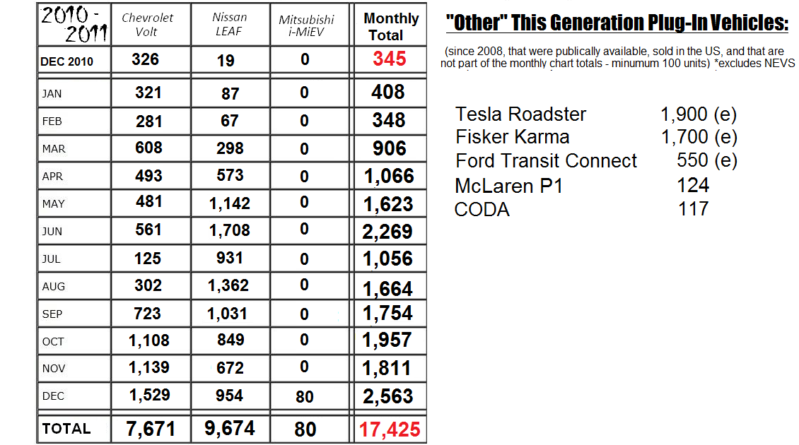

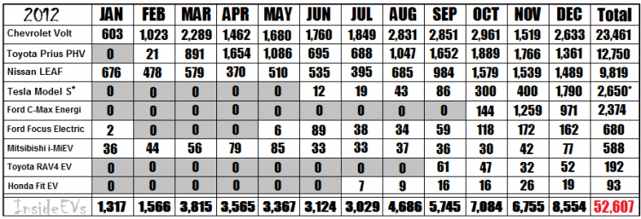

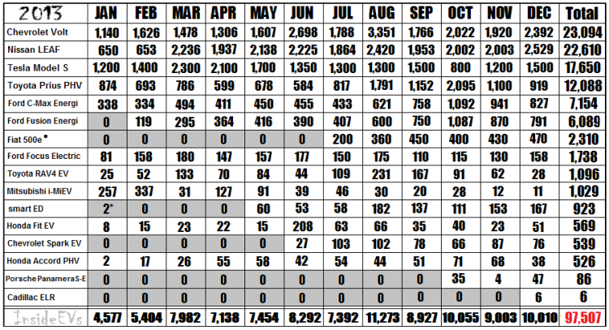

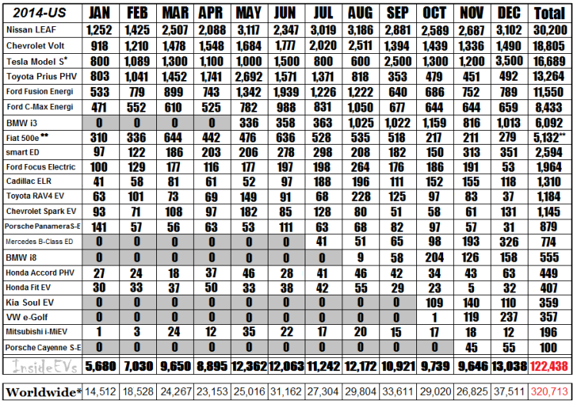

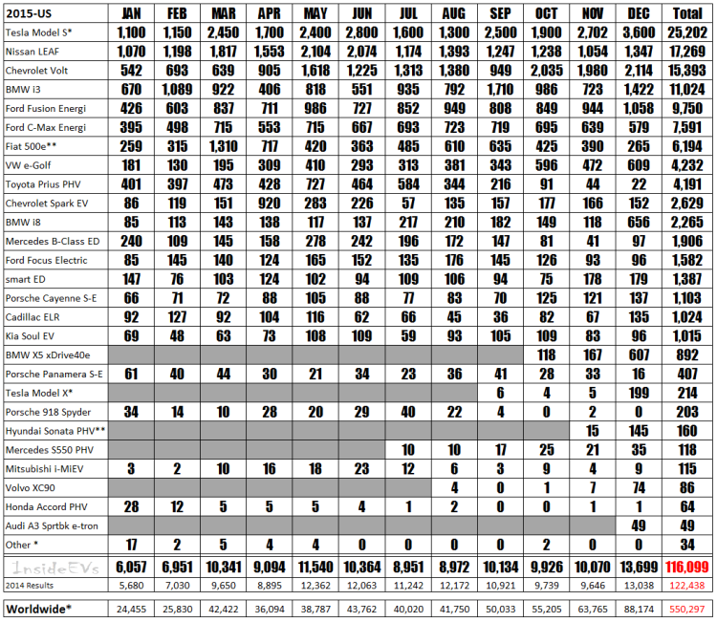

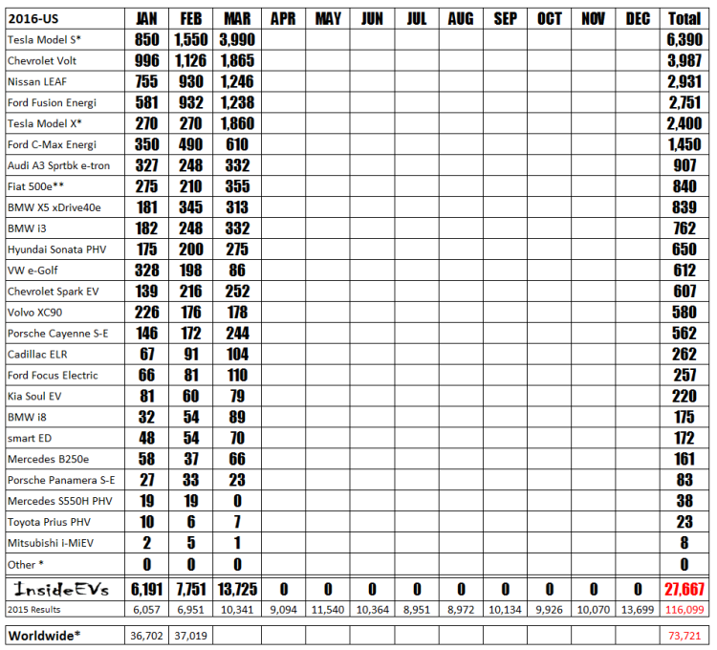

|  |  |  |  |  |  |  |  |  |  |  |  |  |
| --- | --- | --- | --- | --- | --- | --- | --- | --- | --- | --- | --- | --- |
|  | 2010 | | | | | | | | | | | |
|  | Jan | Feb | Mar | Apr | May | Jun | Jul | Aug | Sep | Oct | Nov | Dec |
| Price Per Unit Tesla |  |  |  |  |  |  |  |  |  |  |  | $ - |
| Price Per Unit All Electric minus outliers |  |  |  |  |  |  |  |  |  |  |  | $ 33,767 |
| All (-) Tesla Price Per Unit |  |  |  |  |  |  |  |  |  |  |  | $ 33,767 |

|  |  |  |  |  |  |  |  |  |  |  |  |  |
| --- | --- | --- | --- | --- | --- | --- | --- | --- | --- | --- | --- | --- |
|  | 2011 | | | | | | | | | | | |
|  | Jan | Feb | Mar | Apr | May | Jun | Jul | Aug | Sep | Oct | Nov | Dec |
| Price Per Unit Tesla | $ - | $ - | $ - | $ - | $ - | $ - | $ - | $ - | $ - | $ - | $ - | $ - |
| Price Per Unit All Electric minus outliers | $ 33,113 | $ 33,199 | $ 32,635 | $ 31,772 | $ 31,085 | $ 30,882 | $ 30,349 | $ 30,610 | $ 31,564 | $ 32,201 | $ 32,461 | $ 32,139 |
| All (-) Tesla Price Per Unit | $ 33,113 | $ 33,199 | $ 32,635 | $ 31,772 | $ 31,085 | $ 30,882 | $ 30,349 | $ 30,610 | $ 31,564 | $ 32,201 | $ 32,461 | $ 32,139 |

|  |  |  |  |  |  |  |  |  |  |  |  |  |
| --- | --- | --- | --- | --- | --- | --- | --- | --- | --- | --- | --- | --- |
|  | 2012 | | | | | | | | | | | |
|  | Jan | Feb | Mar | Apr | May | Jun | Jul | Aug | Sep | Oct | Nov | Dec |
| Price Per Unit Tesla | $- | $- | $- | $- | $- | $88,700 | $88,700 | $88,700 | $88,700 | $88,700 | $88,700 | $88,700 |
| Price Per Unit All Electric minus outliers | $31,589 | $32,189 | $28,709 | $24,382 | $26,877 | $28,980 | $29,258 | $29,474 | $28,624 | $30,215 | $30,913 | $41,432 |
| All (-) Tesla Price Per Unit | $31,589 | $32,189 | $28,709 | $24,382 | $26,877 | $28,750 | $28,883 | $28,926 | $27,711 | $27,629 | $27,275 | $28,923 |

|  |  |  |  |  |  |  |  |  |  |  |  |  |
| --- | --- | --- | --- | --- | --- | --- | --- | --- | --- | --- | --- | --- |
|  | 2013 | | | | | | | | | | | |
|  | Jan | Feb | Mar | Apr | May | Jun | Jul | Aug | Sep | Oct | Nov | Dec |
| Price Per Unit Tesla | $88,700 | $88,700 | $88,700 | $88,700 | $88,700 | $88,700 | $88,700 | $88,700 | $88,700 | $88,700 | $88,700 | $88,700 |
| Price Per Unit All Electric minus outliers | $43,413 | $44,553 | $46,804 | $47,254 | $43,445 | $40,409 | $40,161 | $36,112 | $39,201 | $33,333 | $37,366 | $38,870 |
| All (-) Tesla Price Per Unit | $27,320 | $29,117 | $29,845 | $29,977 | $30,074 | $30,981 | $29,966 | $29,430 | $29,680 | $28,714 | $29,810 | $30,475 |

|  |  |  |  |  |  |  |  |  |  |  |  |  |
| --- | --- | --- | --- | --- | --- | --- | --- | --- | --- | --- | --- | --- |
|  | 2014 | | | | | | | | | | | |
|  | Jan | Feb | Mar | Apr | May | Jun | Jul | Aug | Sep | Oct | Nov | Dec |
| Price Per Unit Tesla | $88,700 | $88,700 | $88,700 | $88,700 | $88,700 | $88,700 | $88,700 | $88,700 | $88,700 | $88,700 | $88,700 | $88,700 |
| Price Per Unit All Electric minus outliers | $39,486 | $39,197 | $37,551 | $36,303 | $33,596 | $39,477 | $35,174 | $35,942 | $46,861 | $43,551 | $41,603 | $48,905 |
| All (-) Tesla Price Per Unit | $31,471 | $30,409 | $29,821 | $29,065 | $28,961 | $31,592 | $31,208 | $33,233 | $34,505 | $36,767 | $35,067 | $35,045 |
|  |  | | | | | | | | | | | |
|  | 2015 | | | | | | | | | | | |
|  | Jan | Feb | Mar | Apr | May | Jun | Jul | Aug | Sep | Oct | Nov | Dec |
| Price Per Unit Tesla | $88,700 | $88,700 | $88,700 | $88,700 | $88,700 | $88,700 | $88,700 | $88,700 | $88,682 | $88,684 | $88,686 | $88,307 |
| Price Per Unit All Electric minus outliers | $45,637 | $45,488 | $48,108 | $44,549 | $45,627 | $49,448 | $46,141 | $44,350 | $50,473 | $47,288 | $51,003 | $56,782 |
| All (-) Tesla Price Per Unit | $35,928 | $36,898 | $35,482 | $34,354 | $34,287 | $34,863 | $36,827 | $36,813 | $37,914 | $37,461 | $37,184 | $44,635 |

|  |  |  |  |  |  |  |  |  |  |  |  |  |
| --- | --- | --- | --- | --- | --- | --- | --- | --- | --- | --- | --- | --- |
|  | 2016 | | | | | | | | | | | |
|  | Jan | Feb | Mar | Apr | May | Jun | Jul | Aug | Sep | Oct | Nov | Dec |
| Price Per Unit Tesla | $86,892 | $87,587 | $86,315 |  |  |  |  |  |  |  |  |  |
| Price Per Unit All Electric minus outliers | $47,570 | $50,770 | $58,905 |  |  |  |  |  |  |  |  |  |
| All (-) Tesla Price Per Unit | $38,885 | $39,484 | $38,517 |  |  |  |  |  |  |  |  |  |